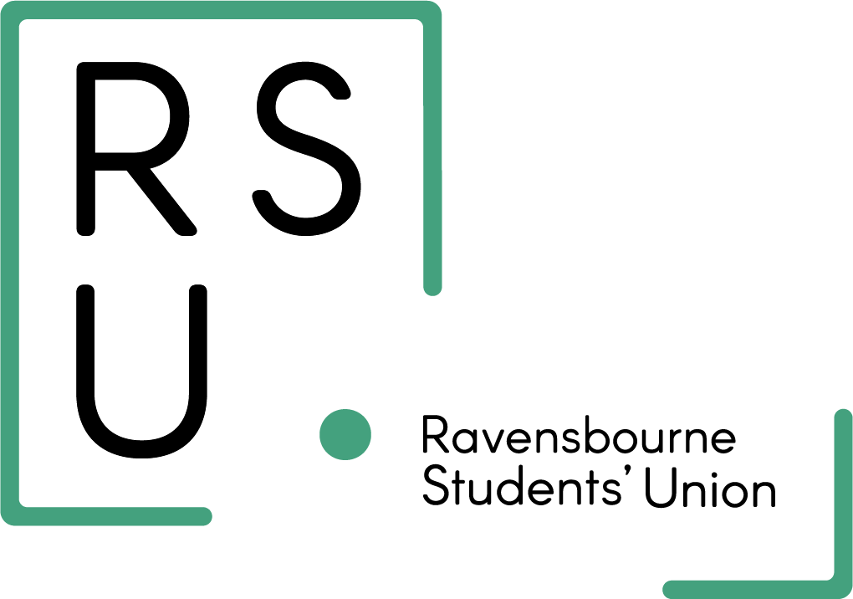

Start a new society form

- What is the name of your society?

- What are your society’s goals and objectives?

- List the names and emails of the committee members/ officers that will run the society. Remember, these members will run the society (design, promote and run events, stay in contact with the SU to be supported).

Position | Student name | Student email address

- What events do you aim to organise? (highlight and/ or add your own)

Social (including movie nights, board games, etc)
Sports (including tournaments, non-competitive matches etc.)
DIY crafts
Panels/Raise Awareness
Workshops/ Skill development

Something else: _________________

- Do you have 7 other students that want to join your society? (delete as appropriate)

YES/NO

- How will you communicate with your society? (Highlight as appropriate)

Instagram
WhatsApp
Student Email
Tik Tok
Facebook

Other: ________________

- Kindly provide the link to your comms channel

- Do you have a society’s logo?

YES/NO

If YES, please send it alongside the completed form in Jpeg or Png format.

Your name:
Your student email:
Year of study:

Please send this form to staars@rave.ac.uk

