HOW TO COMPLETE A RISK ASSESSMENT

- Client/Event Information

Complete this section with details of your event and your details as the person filling the risk assessment. If there are multiple persons involved with the RA, include their details as well.

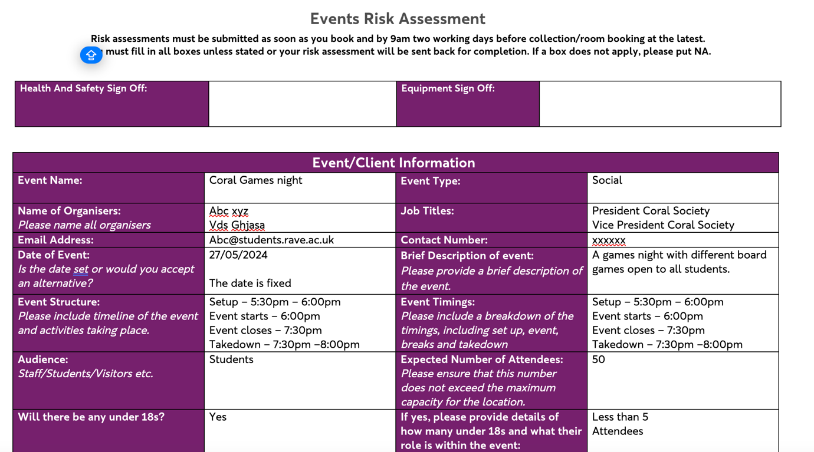

- External Speakers
If you’ll be inviting external guests for your event, complete this section with their details and take note of the extra documentation you need to complete. The RUL external speaker form, otherwise, fill as N/A (Not applicable)

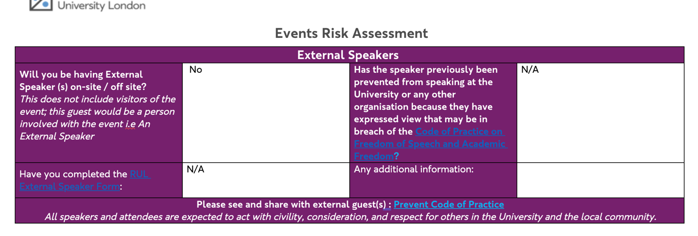

- Registration
Complete this section if you’ll be inviting visitors, for example an external DJ, or performance group or any external guest.
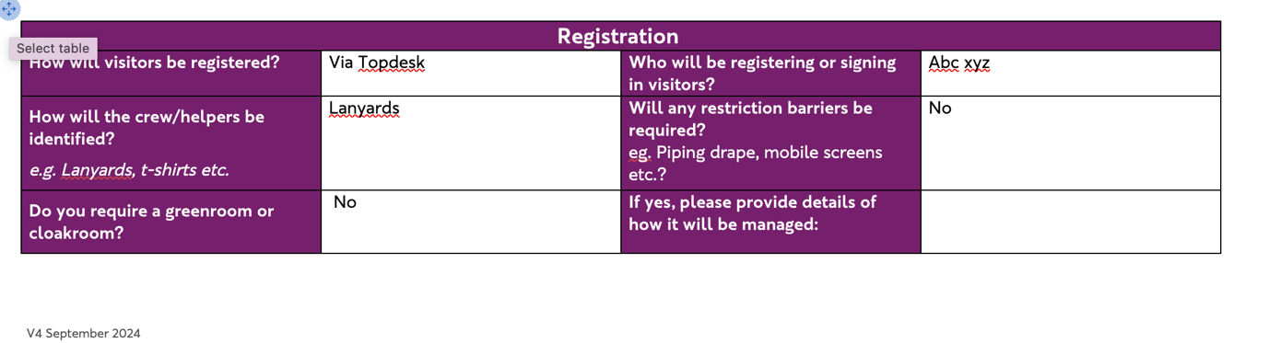

- Hospitality
Complete this section with necessary information regarding catering, whether it’s internal or external caterers. If there’ll be alcohol at the event, there might be extra documentation to complete. Make sure to complete them.

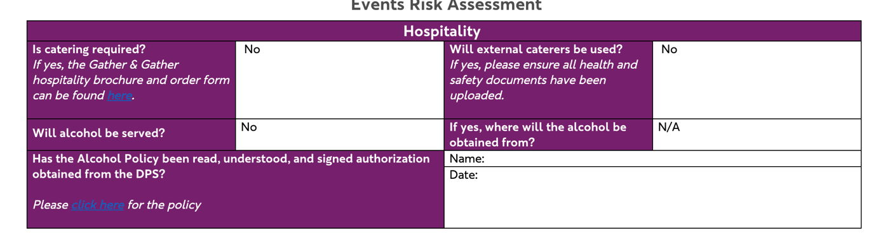

- Facilities
Complete as required. If you’ll be expecting large deliveries such as food or drinks, etc, make sure to complete the information on that.
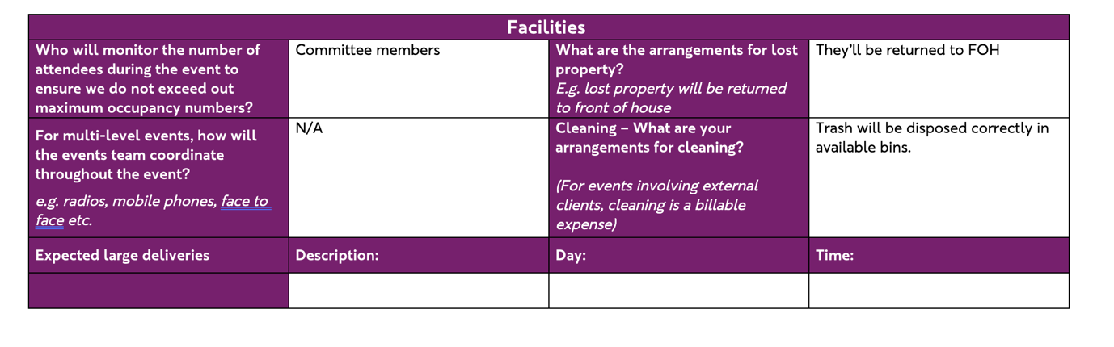

- Event location
Complete this section with information about the room/space you have booked. You should raise a Topdesk ticket for Facilities to help setup your space and include the ticket number on your RA. If you don’t require them to help setup the space, you can complete the relevant places with N/A
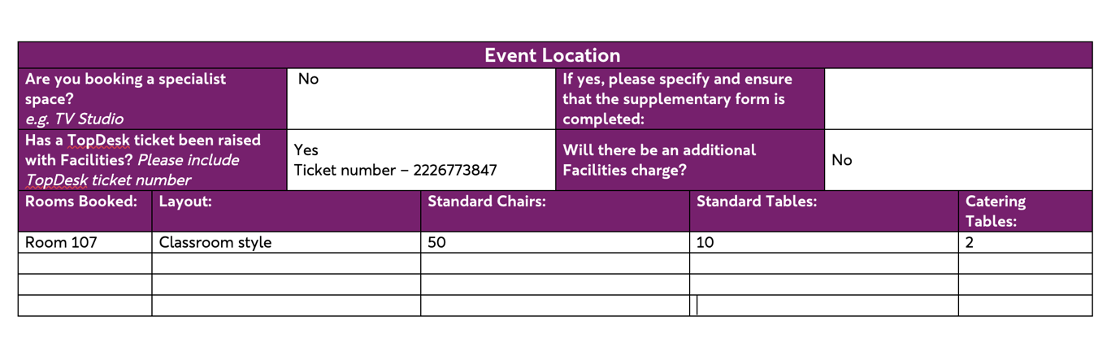

- Access
Provide any information on accessibility as required.
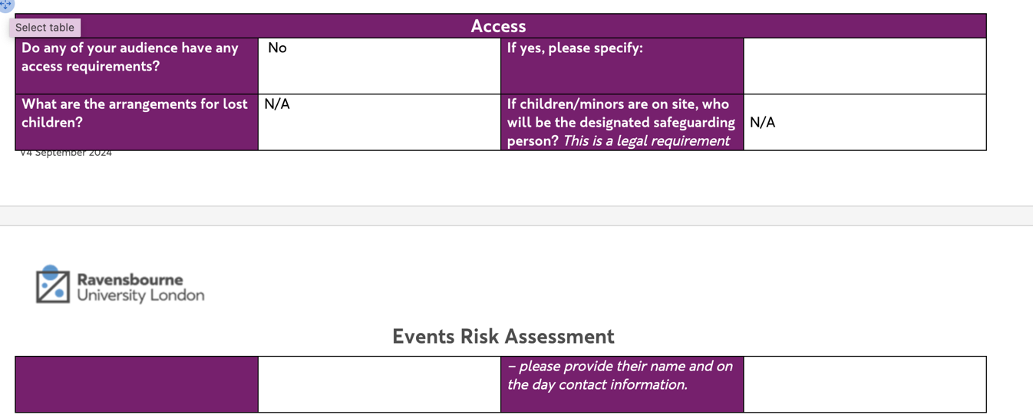

- IT set-up requirements
If you require any IT equipment, you need to have booked that separately via Topdesk and include the ticket number in this section, otherwise fill the section with N/A (Not applicable)
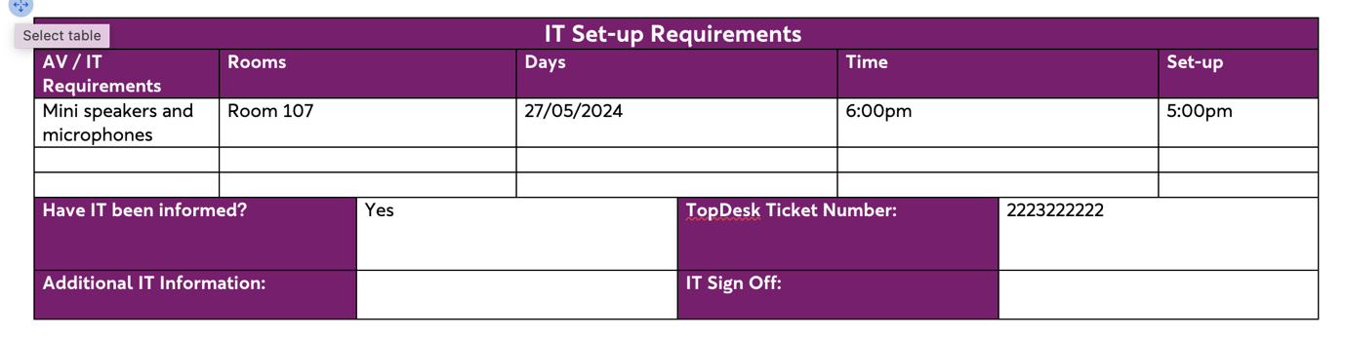

- Kit store/Equipment hire
If you require any equipment from Kitstore, you’ll need to have booked that separately on Topdesk and complete the information as necessary.

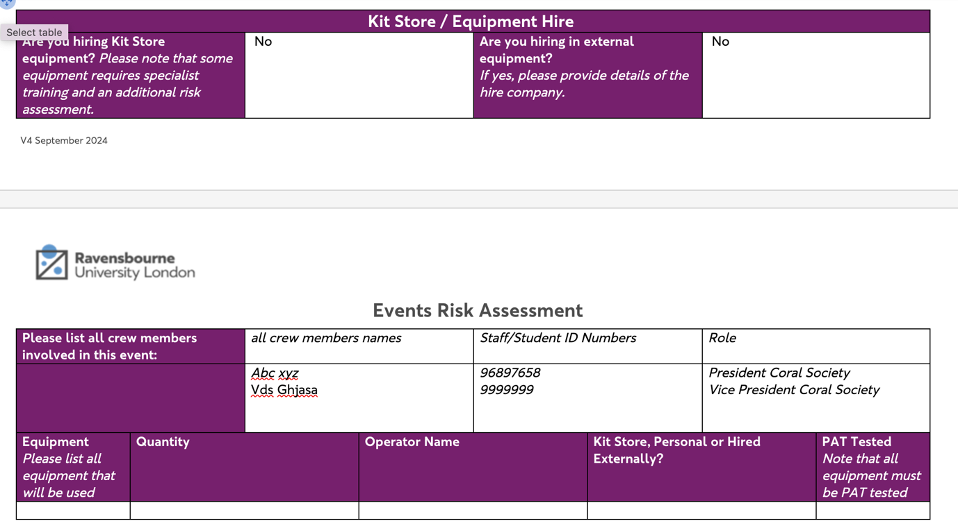

- Health and Safety – External Client Event Documentation
If you are having an external vendor (e.g. DJ, Performance group, external caterers etc), they’ll need to complete and send their risk assessment form to you, which would be included in the folder containing the RA form. Note that other documents may be required of your vendor depending on the services they provide.

- Training needs, Internal only
If you require certain health and safety training such as alcohol training, using a ladder etc, you should request for one here. If you’ll be serving alcohol at your event, you need to be alcohol trained.

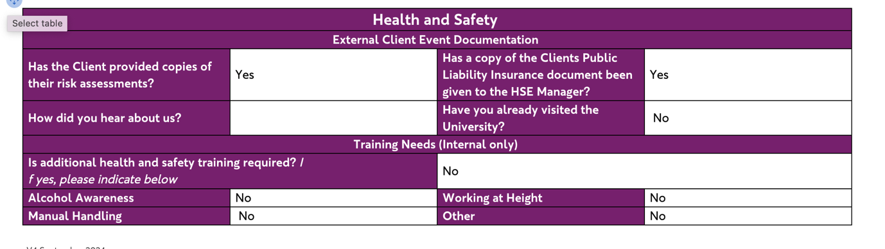

- Hazard lists
Complete this section as thoroughly as possible. Identifying all potential hazards relevant to your event. Tick only the ones relevant to your event.
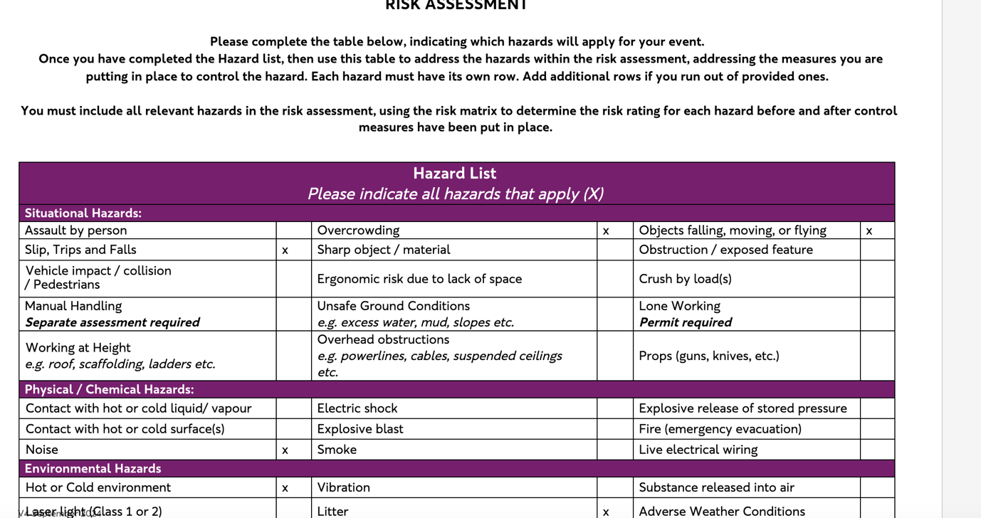

- Risk assessment
Complete this section thoroughly using the hazard lists. Use the risk matrix to rate the level of risk at your event based on the hazard list completed and what they’ll be after the control measures are applied. Ensure that as much as possible the risk becomes low, once control measures are applied.
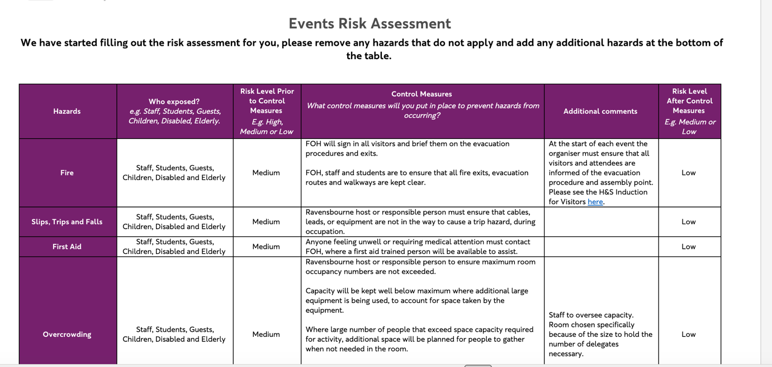

- Additional Hazard
Identify and complete any additional hazard that might be relevant to your event.
For instance, Allergens etc.
- Sign off
Include the date you are completing the risk assessment and your name.
